UNITED STATES
SECURITIES AND EXCHANGE COMMISSION
Washington, D.C. 20549
___________________________________
FORM 8-K
___________________________________
CURRENT REPORT
Pursuant to Section 13 or 15(d)
of the Securities Exchange Act of 1934

Date of Report (date of earliest event reported): September 14, 2026
___________________________________
M&T BANK CORPORATION
(Exact name of registrant as specified in its charter)
___________________________________
 |  |  | New York
(State or other jurisdiction of incorporation)
1-9861  (Commission File Number) |  |  |  |  |  | 16-0968385  (I.R.S. Employer Identification Number)
One M&T Plaza, Buffalo, New York |  |  |  |  |  | 14203
(Address of principal executive offices) |  |  |  |  |  | (Zip Code)
Registrant's telephone number, including area code: (716) 635-4000
___________________________________
Check the appropriate box below if the Form 8-K filing is intended to simultaneously satisfy the filing obligation of the registrant under any of the following provisions (see General Instructions A.2. below):
☐ |  |  | Written communications pursuant to Rule 425 under the Securities Act (17 CFR 230.425)
☐ |  |  | Soliciting material pursuant to Rule 14a-12 under the Exchange Act (17 CFR 240.14a-12)
☐ |  |  | Pre-commencement communications pursuant to Rule 14d-2(b) under the Exchange Act (17 CFR 240.14d-2(b))
☐ |  |  | Pre-commencement communications pursuant to Rule 13e-4(c) under the Exchange Act (17 CFR 240.13e-4(c))
Securities registered pursuant to Section 12(b) of the Act:
Title of Each Class |  |  | Trading Symbols |  |  | Name of Each Exchange on Which Registered
Common Stock, $.50 par value |  |  | MTB |  |  | New York Stock Exchange
Perpetual Fixed-to-Floating Rate  Non-Cumulative Preferred Stock, Series H |  |  | MTBPrH |  |  | New York Stock Exchange
Perpetual Fixed Rate Non-Cumulative  Preferred Stock, Series J |  |  | MTBPrJ |  |  | New York Stock Exchange
Perpetual Fixed Rate Non-Cumulative  Preferred Stock, Series K |  |  | MTBPrK |  |  | New York Stock Exchange
Perpetual Fixed Rate Non-Cumulative  Preferred Stock, Series L |  |  | MTBPrL |  |  | New York Stock Exchange
Indicate by check mark whether the registrant is an emerging growth company as defined in Rule 405 of the Securities Act of 1933 (§ 230.405 of this chapter) or Rule 12b-2 of the Securities Exchange Act of 1934 (§ 240.12b-2 of this chapter).
Emerging growth company ☐
If an emerging growth company, indicate by check mark if the registrant has elected not to use the extended transition period for complying with any new or revised financial accounting standards provided pursuant to Section 13(a) of the Exchange Act. ☐

Item 7.01. Regulation FD Disclosure.
On September 14, 2026, M&T Bank Corporation (“M&T”) posted an investor presentation to its website. A copy of the presentation is attached as Exhibit 99.1 hereto. From time to time, M&T may use this presentation in conversations with investors and analysts. The presentation can be found on the Investor Relations page of M&T’s website at ir.mtb.com/events-presentations.

The information in this Form 8-K, including Exhibit 99.1 attached hereto, shall not be deemed to be “filed” for purposes of Section 18 of the Securities Exchange Act of 1934 (the "Exchange Act"), or otherwise subject to the liability of such section, nor shall it be deemed incorporated by reference in any filing of M&T under the Securities Act of 1933 or the Exchange Act, regardless of any general incorporation language in such filing, unless expressly incorporated by specific reference in such filing.

Item 9.01 - Financial Statements and Exhibits
(d) The following exhibits are being filed herewith:

Exhibit No. |  |  |  |  |  | Exhibit Description
99.1 |  |  |  |  |  | M&T Bank Corporation presentation dated September 14, 2026
104 |  |  |  |  |  | Cover Page Interactive Data File (embedded within the Inline XBRL document)

SIGNATURE

Pursuant to the requirements of the Securities Exchange Act of 1934, as amended, the Registrant has duly caused this report to be signed on its behalf by the undersigned hereunto duly authorized.

 |  |  |  |  |  |  |  |  |  |  |  | M&T BANK CORPORATION
Date: |  |  | September 14, 2026 |  |  |  |  |  |  |  |  | By: |  |  | /s/ Daryl N. Bible
 |  |  |  |  |  |  |  |  |  |  |  |  |  |  | Daryl N. Bible
Senior Executive Vice President
and Chief Financial Officer



Investor Update 3rd Quarter 2026 SEPTEMBER 2026 Exhibit 99.1

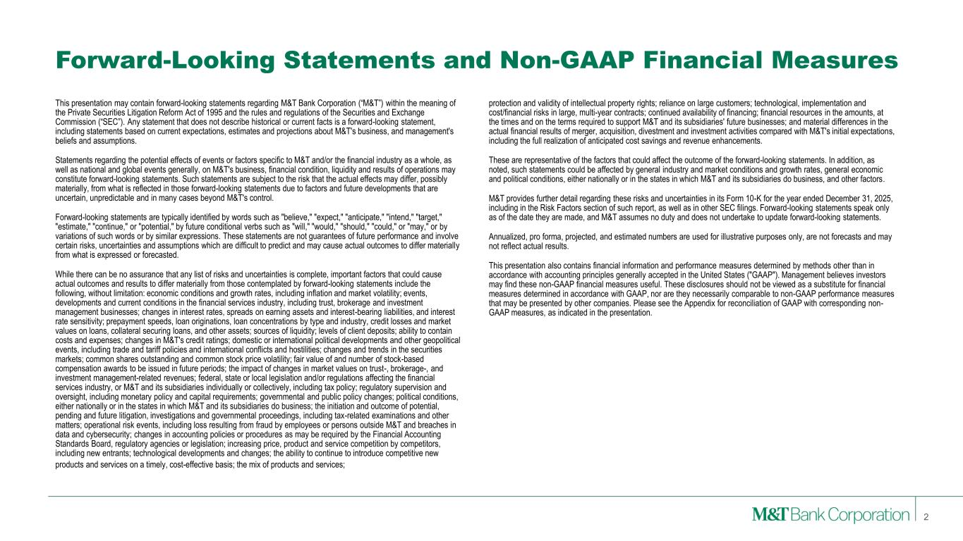
Forward-Looking Statements and Non-GAAP Financial Measures 2 This presentation may contain forward-looking statements regarding M&T Bank Corporation (“M&T”) within the meaning of the Private Securities Litigation Reform Act of 1995 and the rules and regulations of the Securities and Exchange Commission (“SEC”). Any statement that does not describe historical or current facts is a forward-looking statement, including statements based on current expectations, estimates and projections about M&T's business, and management's beliefs and assumptions. Statements regarding the potential effects of events or factors specific to M&T and/or the financial industry as a whole, as well as national and global events generally, on M&T's business, financial condition, liquidity and results of operations may constitute forward-looking statements. Such statements are subject to the risk that the actual effects may differ, possibly materially, from what is reflected in those forward-looking statements due to factors and future developments that are uncertain, unpredictable and in many cases beyond M&T's control. Forward-looking statements are typically identified by words such as "believe," "expect," "anticipate," "intend," "target," "estimate," "continue," or "potential," by future conditional verbs such as "will," "would," "should," "could," or "may," or by variations of such words or by similar expressions. These statements are not guarantees of future performance and involve certain risks, uncertainties and assumptions which are difficult to predict and may cause actual outcomes to differ materially from what is expressed or forecasted. While there can be no assurance that any list of risks and uncertainties is complete, important factors that could cause actual outcomes and results to differ materially from those contemplated by forward-looking statements include the following, without limitation: economic conditions and growth rates, including inflation and market volatility; events, developments and current conditions in the financial services industry, including trust, brokerage and investment management businesses; changes in interest rates, spreads on earning assets and interest-bearing liabilities, and interest rate sensitivity; prepayment speeds, loan originations, loan concentrations by type and industry, credit losses and market values on loans, collateral securing loans, and other assets; sources of liquidity; levels of client deposits; ability to contain costs and expenses; changes in M&T's credit ratings; domestic or international political developments and other geopolitical events, including trade and tariff policies and international conflicts and hostilities; changes and trends in the securities markets; common shares outstanding and common stock price volatility; fair value of and number of stock-based compensation awards to be issued in future periods; the impact of changes in market values on trust-, brokerage-, and investment management-related revenues; federal, state or local legislation and/or regulations affecting the financial services industry, or M&T and its subsidiaries individually or collectively, including tax policy; regulatory supervision and oversight, including monetary policy and capital requirements; governmental and public policy changes; political conditions, either nationally or in the states in which M&T and its subsidiaries do business; the initiation and outcome of potential, pending and future litigation, investigations and governmental proceedings, including tax-related examinations and other matters; operational risk events, including loss resulting from fraud by employees or persons outside M&T and breaches in data and cybersecurity; changes in accounting policies or procedures as may be required by the Financial Accounting Standards Board, regulatory agencies or legislation; increasing price, product and service competition by competitors, including new entrants; technological developments and changes; the ability to continue to introduce competitive new products and services on a timely, cost-effective basis; the mix of products and services; protection and validity of intellectual property rights; reliance on large customers; technological, implementation and cost/financial risks in large, multi-year contracts; continued availability of financing; financial resources in the amounts, at the times and on the terms required to support M&T and its subsidiaries' future businesses; and material differences in the actual financial results of merger, acquisition, divestment and investment activities compared with M&T's initial expectations, including the full realization of anticipated cost savings and revenue enhancements. These are representative of the factors that could affect the outcome of the forward-looking statements. In addition, as noted, such statements could be affected by general industry and market conditions and growth rates, general economic and political conditions, either nationally or in the states in which M&T and its subsidiaries do business, and other factors. M&T provides further detail regarding these risks and uncertainties in its Form 10-K for the year ended December 31, 2025, including in the Risk Factors section of such report, as well as in other SEC filings. Forward-looking statements speak only as of the date they are made, and M&T assumes no duty and does not undertake to update forward-looking statements. Annualized, pro forma, projected, and estimated numbers are used for illustrative purposes only, are not forecasts and may not reflect actual results. This presentation also contains financial information and performance measures determined by methods other than in accordance with accounting principles generally accepted in the United States ("GAAP"). Management believes investors may find these non-GAAP financial measures useful. These disclosures should not be viewed as a substitute for financial measures determined in accordance with GAAP, nor are they necessarily comparable to non-GAAP performance measures that may be presented by other companies. Please see the Appendix for reconciliation of GAAP with corresponding non- GAAP measures, as indicated in the presentation.

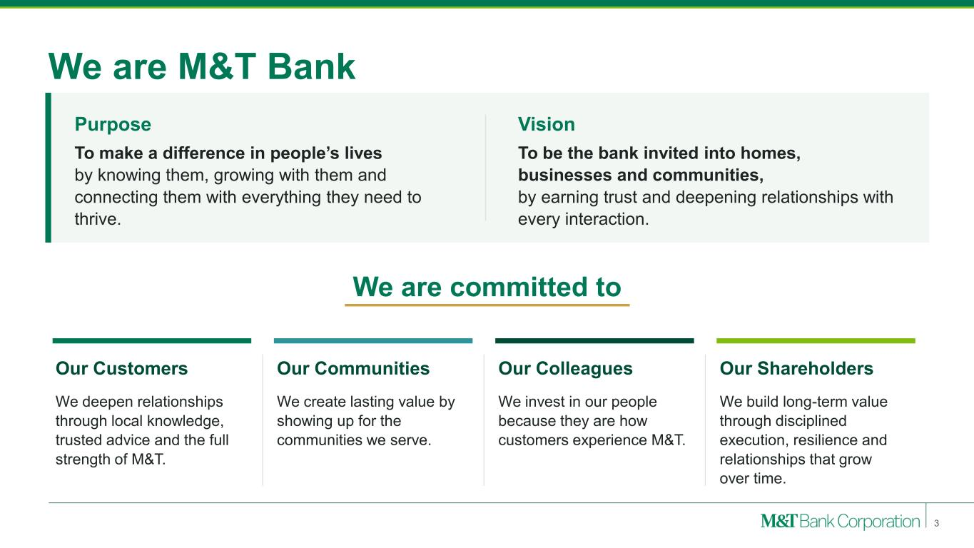
We are M&T Bank Purpose To make a difference in people’s lives by knowing them, growing with them and connecting them with everything they need to thrive. Vision To be the bank invited into homes, businesses and communities, by earning trust and deepening relationships with every interaction. We are committed to Our Customers We deepen relationships through local knowledge, trusted advice and the full strength of M&T. Our Communities We create lasting value by showing up for the communities we serve. Our Colleagues We invest in our people because they are how customers experience M&T. Our Shareholders We build long-term value through disciplined execution, resilience and relationships that grow over time. 3

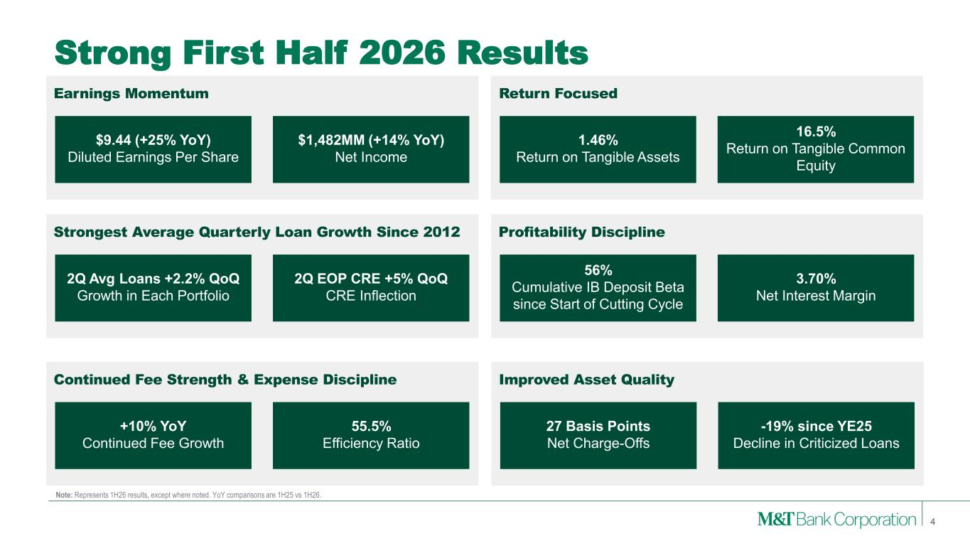
Strong First Half 2026 Results 4 $9.44 (+25% YoY) Diluted Earnings Per Share Outcomes Earnings Momentum Return Focused $1,482MM (+14% YoY) Net Income 1.46% Return on Tangible Assets 16.5% Return on Tangible Common Equity 56% Cumulative IB Deposit Beta since Start of Cutting Cycle Profitability Discipline 3.70% Net Interest Margin 27 Basis Points Net Charge-Offs Improved Asset Quality -19% since YE25 Decline in Criticized Loans +10% YoY Continued Fee Growth Continued Fee Strength & Expense Discipline 55.5% Efficiency Ratio 2Q Avg Loans +2.2% QoQ Growth in Each Portfolio Strongest Average Quarterly Loan Growth Since 2012 2Q EOP CRE +5% QoQ CRE Inflection Note: Represents 1H26 results, except where noted. YoY comparisons are 1H25 vs 1H26.

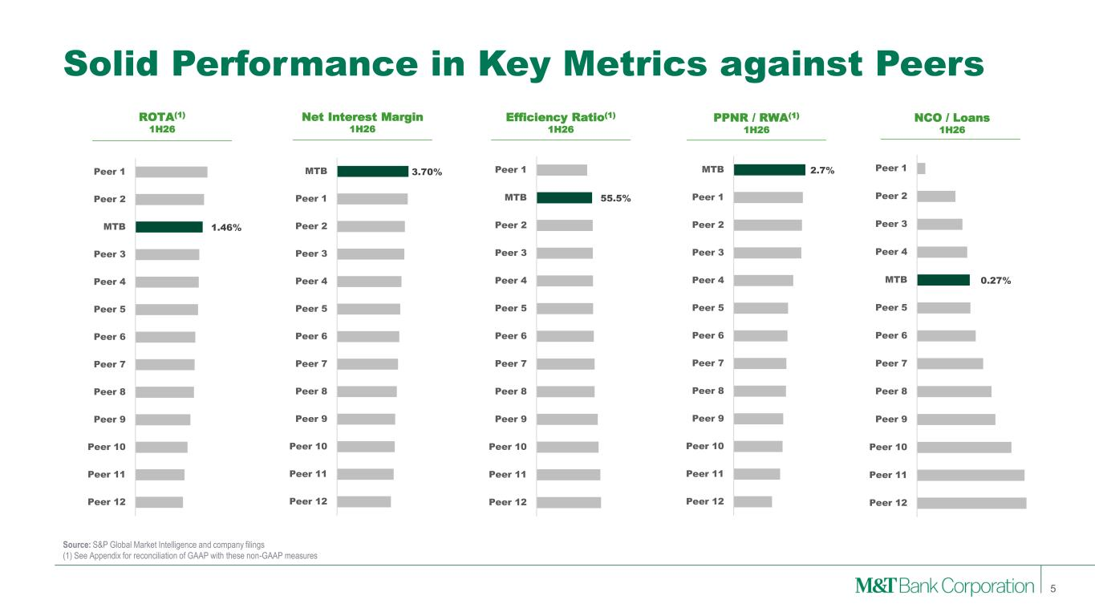
Solid Performance in Key Metrics against Peers 5 ROTA(1) 1H26 Net Interest Margin 1H26 Efficiency Ratio(1) 1H26 PPNR / RWA(1) 1H26 NCO / Loans 1H26 Source: S&P Global Market Intelligence and company filings (1) See Appendix for reconciliation of GAAP with these non-GAAP measures 1.46% Peer 1 Peer 2 MTB Peer 3 Peer 4 Peer 5 Peer 6 Peer 7 Peer 8 Peer 9 Peer 10 Peer 11 Peer 12 3.70% MTB Peer 1 Peer 2 Peer 3 Peer 4 Peer 5 Peer 6 Peer 7 Peer 8 Peer 9 Peer 10 Peer 11 Peer 12 55.5% Peer 1 MTB Peer 2 Peer 3 Peer 4 Peer 5 Peer 6 Peer 7 Peer 8 Peer 9 Peer 10 Peer 11 Peer 12 2.7% MTB Peer 1 Peer 2 Peer 3 Peer 4 Peer 5 Peer 6 Peer 7 Peer 8 Peer 9 Peer 10 Peer 11 Peer 12 0.27% Peer 1 Peer 2 Peer 3 Peer 4 MTB Peer 5 Peer 6 Peer 7 Peer 8 Peer 9 Peer 10 Peer 11 Peer 12

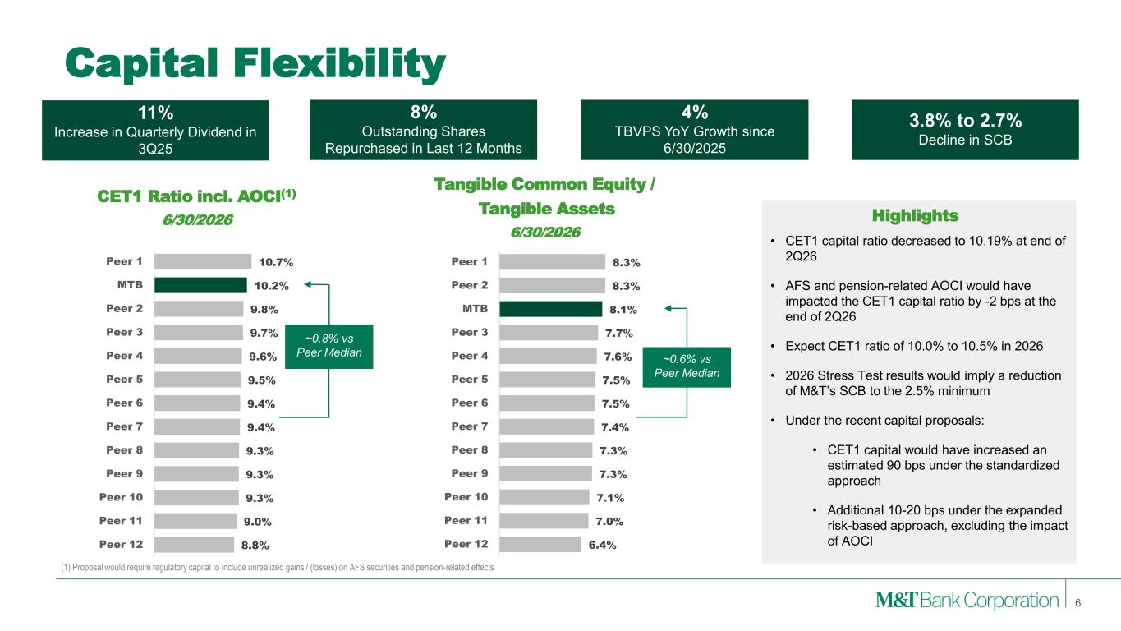
6.4% 7.0% 7.1% 7.3% 7.3% 7.4% 7.5% 7.5% 7.6% 7.7% 8.1% 8.3% 8.3% Peer 12 Peer 11 Peer 10 Peer 9 Peer 8 Peer 7 Peer 6 Peer 5 Peer 4 Peer 3 MTB Peer 2 Peer 1 8.8% 9.0% 9.3% 9.3% 9.3% 9.4% 9.4% 9.5% 9.6% 9.7% 9.8% 10.2% 10.7% Peer 12 Peer 11 Peer 10 Peer 9 Peer 8 Peer 7 Peer 6 Peer 5 Peer 4 Peer 3 Peer 2 MTB Peer 1 Capital Flexibility • CET1 capital ratio decreased to 10.19% at end of 2Q26 • AFS and pension-related AOCI would have impacted the CET1 capital ratio by -2 bps at the end of 2Q26 • Expect CET1 ratio of 10.0% to 10.5% in 2026 • 2026 Stress Test results would imply a reduction of M&T’s SCB to the 2.5% minimum • Under the recent capital proposals: • CET1 capital would have increased an estimated 90 bps under the standardized approach • Additional 10-20 bps under the expanded risk-based approach, excluding the impact of AOCI CET1 Ratio incl. AOCI(1) 6/30/2026 Tangible Common Equity / Tangible Assets 6/30/2026 Highlights 6 ~0.6% vs Peer Median ~0.8% vs Peer Median 3.8% to 2.7% Decline in SCB 4% TBVPS YoY Growth since 6/30/2025 8% Outstanding Shares Repurchased in Last 12 Months 11% Increase in Quarterly Dividend in 3Q25 (1) Proposal would require regulatory capital to include unrealized gains / (losses) on AFS securities and pension-related effects

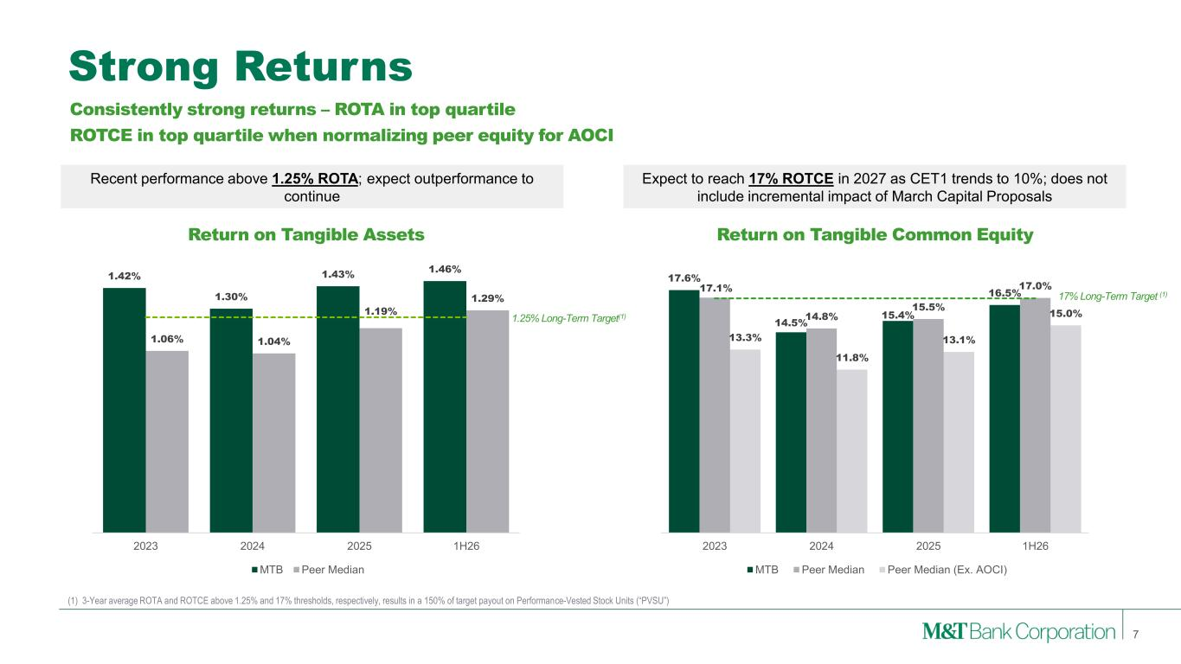
Strong Returns 7 (1) 3-Year average ROTA and ROTCE above 1.25% and 17% thresholds, respectively, results in a 150% of target payout on Performance-Vested Stock Units (“PVSU”) Return on Tangible Assets Return on Tangible Common Equity 1.25% Long-Term Target(1) 17% Long-Term Target (1) Consistently strong returns – ROTA in top quartile ROTCE in top quartile when normalizing peer equity for AOCI Recent performance above 1.25% ROTA; expect outperformance to continue Expect to reach 17% ROTCE in 2027 as CET1 trends to 10%; does not include incremental impact of March Capital Proposals 1.42% 1.30% 1.43% 1.46% 1.06% 1.04% 1.19% 1.29% 2023 2024 2025 1H26 MTB Peer Median 17.6% 14.5% 15.4% 16.5% 17.1% 14.8% 15.5% 17.0% 13.3% 11.8% 13.1% 15.0% 2023 2024 2025 1H26 MTB Peer Median Peer Median (Ex. AOCI)

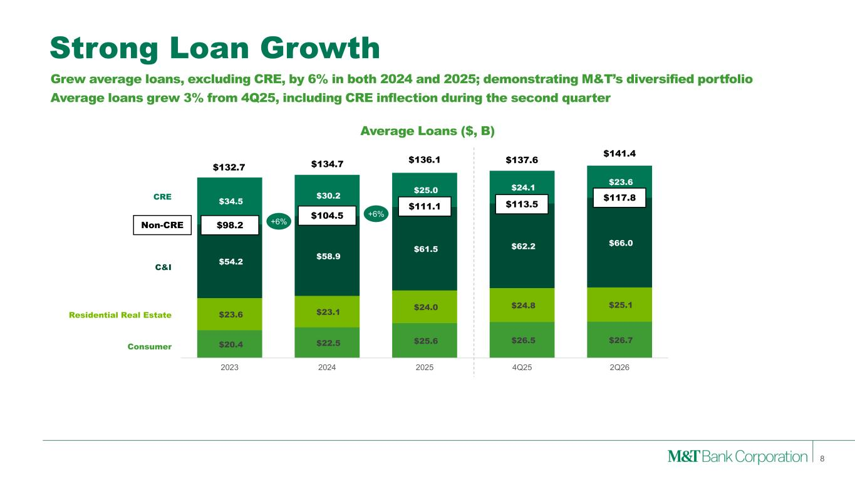
$20.4 $22.5 $25.6 $26.5 $26.7 $23.6 $23.1 $24.0 $24.8 $25.1 $54.2 $58.9 $61.5 $62.2 $66.0 $34.5 $30.2 $25.0 $24.1 $23.6 2023 2024 2025 4Q25 2Q26 Strong Loan Growth 8 $132.7 $134.7 $136.1 $98.2 $104.5 $111.1 +6% +6% Consumer Residential Real Estate C&I CRE Grew average loans, excluding CRE, by 6% in both 2024 and 2025; demonstrating M&T’s diversified portfolio Average loans grew 3% from 4Q25, including CRE inflection during the second quarter Average Loans ($, B) Non-CRE $117.8 $141.4 $137.6 $113.5

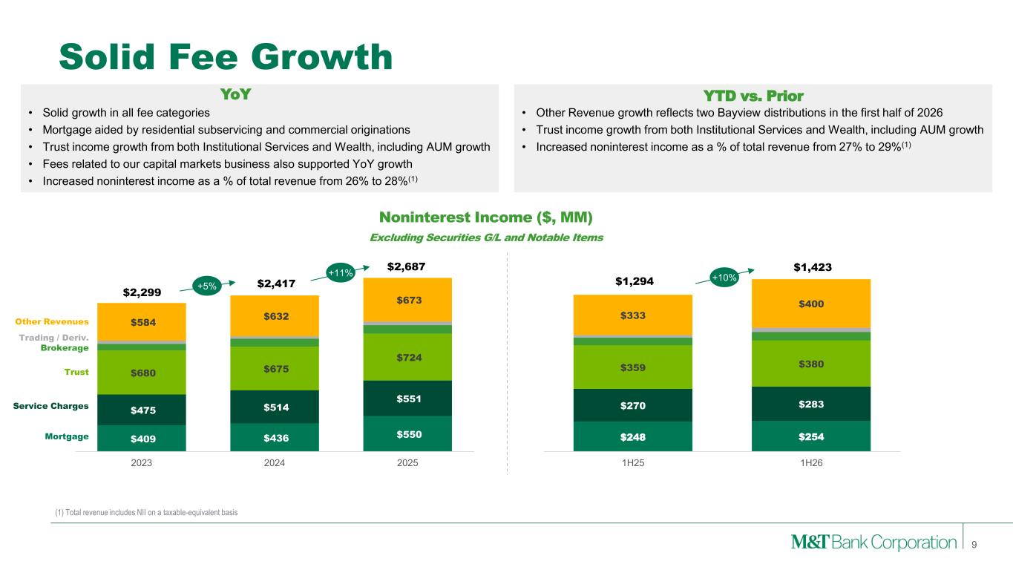
$409 $436 $550 $475 $514 $551 $680 $675 $724 $584 $632 $673 2023 2024 2025 Solid Fee Growth 9 Noninterest Income ($, MM) Excluding Securities G/L and Notable Items $2,299 $2,417 $2,687 +5% +11% • Solid growth in all fee categories • Mortgage aided by residential subservicing and commercial originations • Trust income growth from both Institutional Services and Wealth, including AUM growth • Fees related to our capital markets business also supported YoY growth • Increased noninterest income as a % of total revenue from 26% to 28%(1) Trust Service Charges Mortgage Brokerage Trading / Deriv. Other Revenues $248 $254 $270 $283 $359 $380 $333 $400 1H25 1H26 $1,294 $1,423 +10% • Other Revenue growth reflects two Bayview distributions in the first half of 2026 • Trust income growth from both Institutional Services and Wealth, including AUM growth • Increased noninterest income as a % of total revenue from 27% to 29%(1) YoY YTD vs. Prior (1) Total revenue includes NII on a taxable-equivalent basis

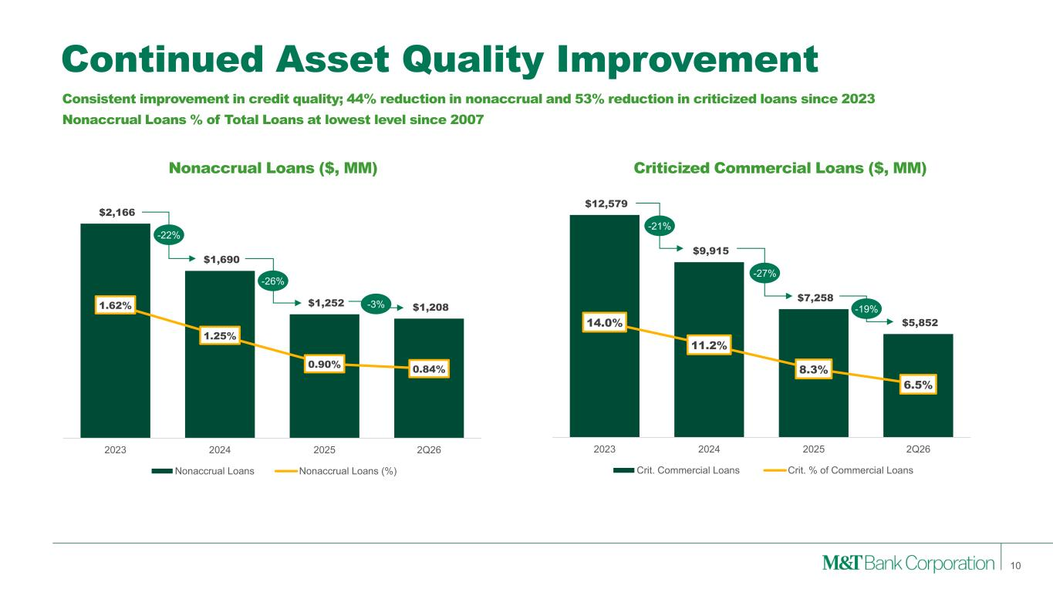
$2,166 $1,690 $1,252 $1,208 1.62% 1.25% 0.90% 0.84% 2023 2024 2025 2Q26 Nonaccrual Loans Nonaccrual Loans (%) Continued Asset Quality Improvement 10 Nonaccrual Loans ($, MM) Criticized Commercial Loans ($, MM) -22% -26% -21% -27% Consistent improvement in credit quality; 44% reduction in nonaccrual and 53% reduction in criticized loans since 2023 Nonaccrual Loans % of Total Loans at lowest level since 2007 -3% -19% $12,579 $9,915 $7,258 $5,852 14.0% 11.2% 8.3% 6.5% 2023 2024 2025 2Q26 Crit. Commercial Loans Crit. % of Commercial Loans

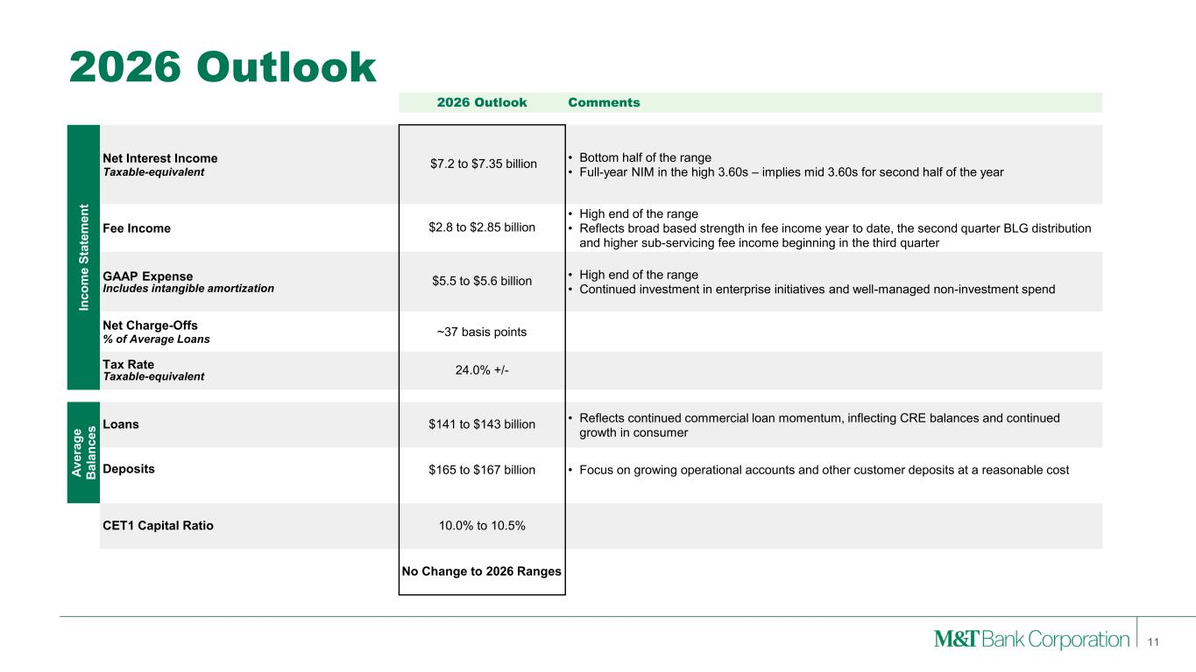
2026 Outlook 11 2026 Outlook Comments In c o m e S ta te m e n t Net Interest Income Taxable-equivalent $7.2 to $7.35 billion • Bottom half of the range • Full-year NIM in the high 3.60s – implies mid 3.60s for second half of the year Fee Income $2.8 to $2.85 billion • High end of the range • Reflects broad based strength in fee income year to date, the second quarter BLG distribution and higher sub-servicing fee income beginning in the third quarter GAAP Expense Includes intangible amortization $5.5 to $5.6 billion • High end of the range • Continued investment in enterprise initiatives and well-managed non-investment spend Net Charge-Offs % of Average Loans ~37 basis points Tax Rate Taxable-equivalent 24.0% +/- A v e ra g e B a la n c e s Loans $141 to $143 billion • Reflects continued commercial loan momentum, inflecting CRE balances and continued growth in consumer Deposits $165 to $167 billion • Focus on growing operational accounts and other customer deposits at a reasonable cost CET1 Capital Ratio 10.0% to 10.5% No Change to 2026 Ranges

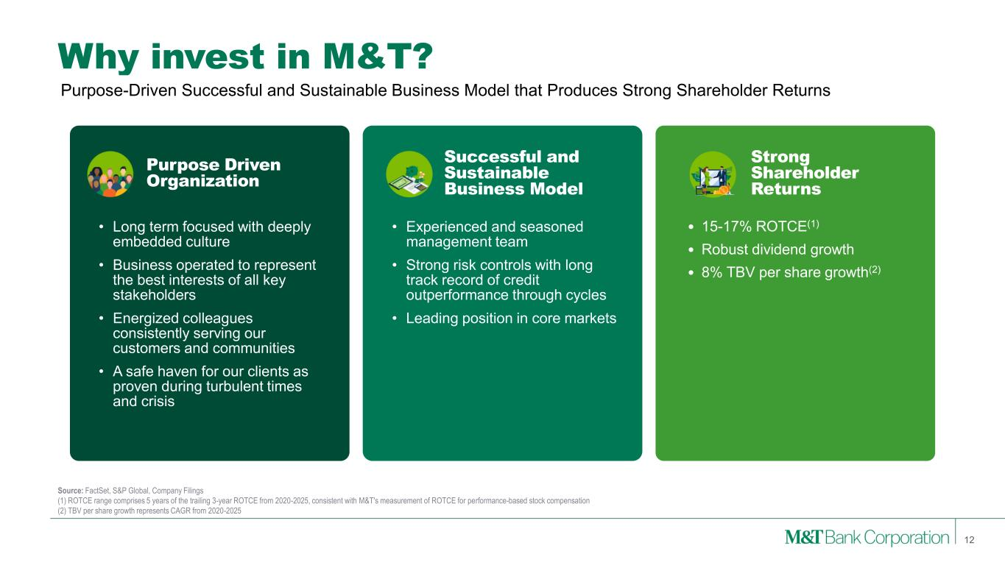
Why invest in M&T? • Long term focused with deeply embedded culture • Business operated to represent the best interests of all key stakeholders • Energized colleagues consistently serving our customers and communities • A safe haven for our clients as proven during turbulent times and crisis • Experienced and seasoned management team • Strong risk controls with long track record of credit outperformance through cycles • Leading position in core markets 12 • 15-17% ROTCE(1) • Robust dividend growth • 8% TBV per share growth(2) Source: FactSet, S&P Global, Company Filings (1) ROTCE range comprises 5 years of the trailing 3-year ROTCE from 2020-2025, consistent with M&T's measurement of ROTCE for performance-based stock compensation (2) TBV per share growth represents CAGR from 2020-2025 Purpose-Driven Successful and Sustainable Business Model that Produces Strong Shareholder Returns Purpose Driven Organization Successful and Sustainable Business Model Strong Shareholder Returns

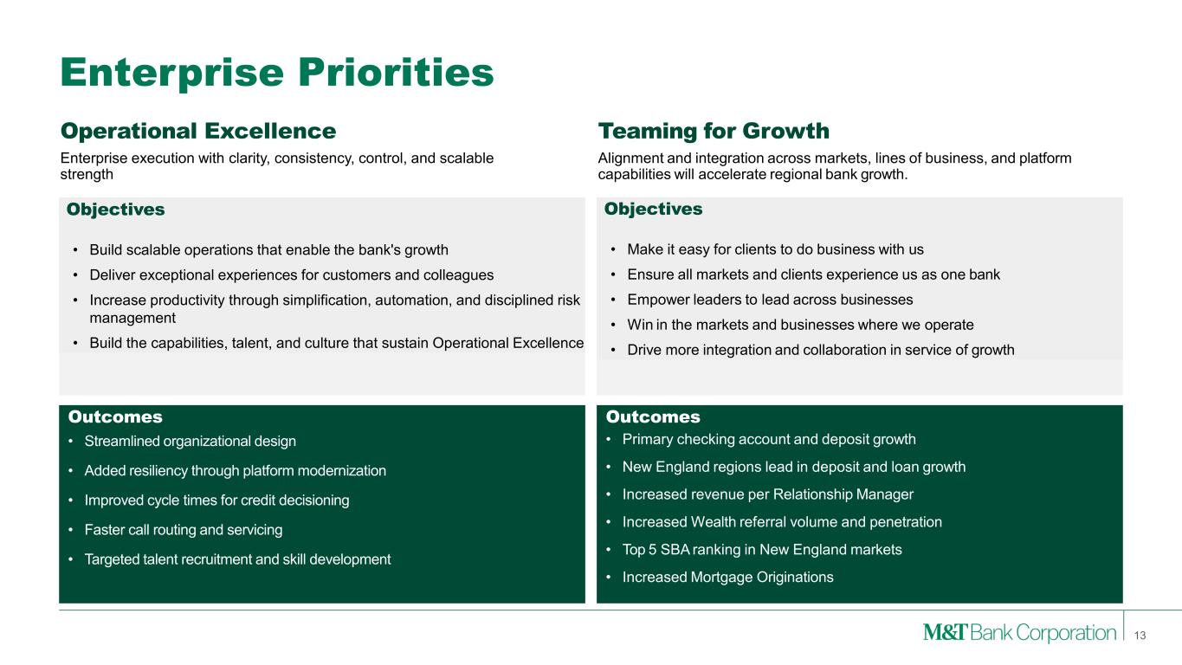
Objectives • Make it easy for clients to do business with us • Ensure all markets and clients experience us as one bank • Empower leaders to lead across businesses • Win in the markets and businesses where we operate • Drive more integration and collaboration in service of growth Operational Excellence Enterprise execution with clarity, consistency, control, and scalable strength Teaming for Growth Alignment and integration across markets, lines of business, and platform capabilities will accelerate regional bank growth. Enterprise Priorities Enterprise Priorities Outcomes • Primary checking account and deposit growth • New England regions lead in deposit and loan growth • Increased revenue per Relationship Manager • Increased Wealth referral volume and penetration • Top 5 SBA ranking in New England markets • Increased Mortgage Originations Outcomes • Streamlined organizational design • Added resiliency through platform modernization • Improved cycle times for credit decisioning • Faster call routing and servicing • Targeted talent recruitment and skill development 13 Objectives • Build scalable operations that enable the bank's growth • Deliver exceptional experiences for customers and colleagues • Increase productivity through simplification, automation, and disciplined risk management • Build the capabilities, talent, and culture that sustain Operational Excellence

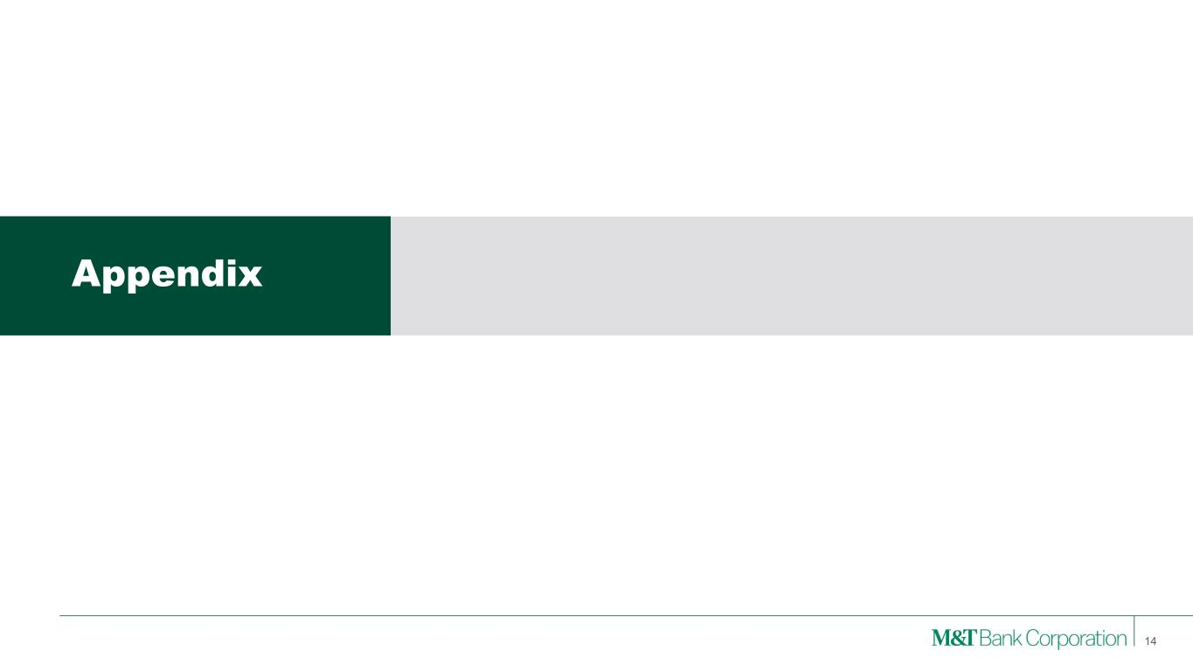
Appendix 14

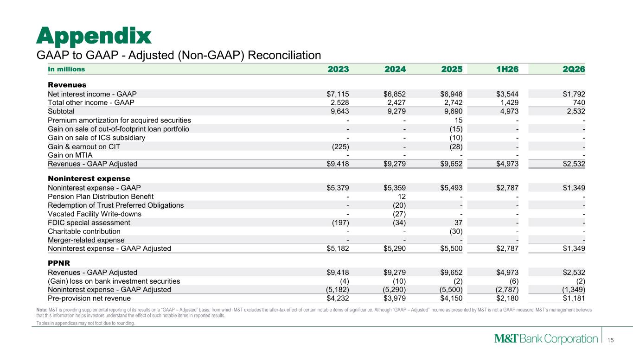
15 Appendix Note: M&T is providing supplemental reporting of its results on a “GAAP – Adjusted” basis, from which M&T excludes the after-tax effect of certain notable items of significance. Although “GAAP – Adjusted” income as presented by M&T is not a GAAP measure, M&T’s management believes that this information helps investors understand the effect of such notable items in reported results. Tables in appendices may not foot due to rounding. GAAP to GAAP - Adjusted (Non-GAAP) Reconciliation In millions 2023 2024 2025 1H26 2Q26 Revenues Net interest income - GAAP $7,115 $6,852 $6,948 $3,544 $1,792 Total other income - GAAP 2,528 2,427 2,742 1,429 740 Subtotal 9,643 9,279 9,690 4,973 2,532 Premium amortization for acquired securities - - 15 - - Gain on sale of out-of-footprint loan portfolio - - (15) - - Gain on sale of ICS subsidiary - - (10) - - Gain & earnout on CIT (225) - (28) - - Gain on MTIA - - - - - Revenues - GAAP Adjusted $9,418 $9,279 $9,652 $4,973 $2,532 Noninterest expense Noninterest expense - GAAP $5,379 $5,359 $5,493 $2,787 $1,349 Pension Plan Distribution Benefit - 12 - - - Redemption of Trust Preferred Obligations - (20) - - - Vacated Facility Write-downs - (27) - - - FDIC special assessment (197) (34) 37 - - Charitable contribution - - (30) - - Merger-related expense - - - - - Noninterest expense - GAAP Adjusted $5,182 $5,290 $5,500 $2,787 $1,349 PPNR Revenues - GAAP Adjusted $9,418 $9,279 $9,652 $4,973 $2,532 (Gain) loss on bank investment securities (4) (10) (2) (6) (2) Noninterest expense - GAAP Adjusted (5,182) (5,290) (5,500) (2,787) (1,349) Pre-provision net revenue $4,232 $3,979 $4,150 $2,180 $1,181

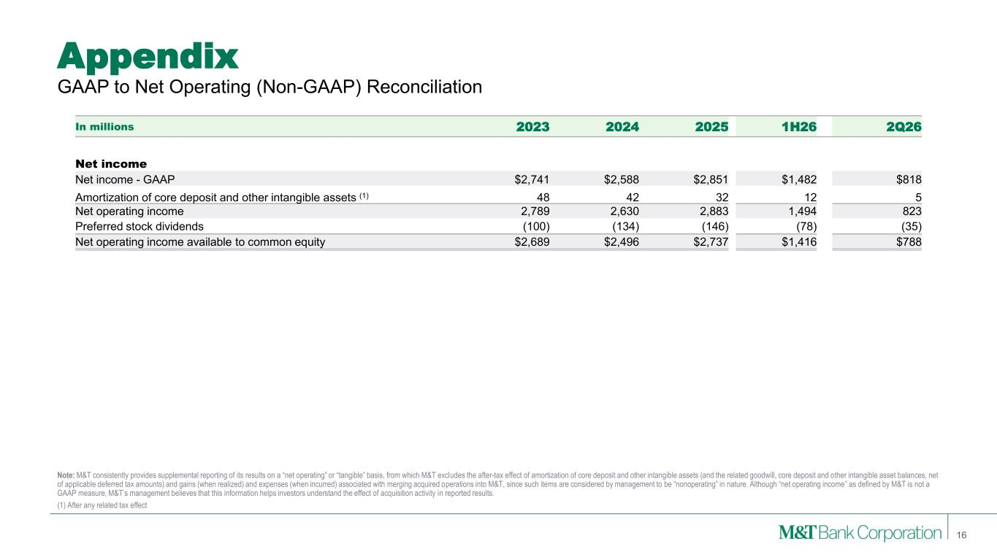
16 Note: M&T consistently provides supplemental reporting of its results on a “net operating” or “tangible” basis, from which M&T excludes the after-tax effect of amortization of core deposit and other intangible assets (and the related goodwill, core deposit and other intangible asset balances, net of applicable deferred tax amounts) and gains (when realized) and expenses (when incurred) associated with merging acquired operations into M&T, since such items are considered by management to be “nonoperating” in nature. Although “net operating income” as defined by M&T is not a GAAP measure, M&T’s management believes that this information helps investors understand the effect of acquisition activity in reported results. (1) After any related tax effect GAAP to Net Operating (Non-GAAP) Reconciliation Appendix In millions 2023 2024 2025 1H26 2Q26 Net income Net income - GAAP $2,741 $2,588 $2,851 $1,482 $818 Amortization of core deposit and other intangible assets (1) 48 42 32 12 5 Net operating income 2,789 2,630 2,883 1,494 823 Preferred stock dividends (100) (134) (146) (78) (35) Net operating income available to common equity $2,689 $2,496 $2,737 $1,416 $788

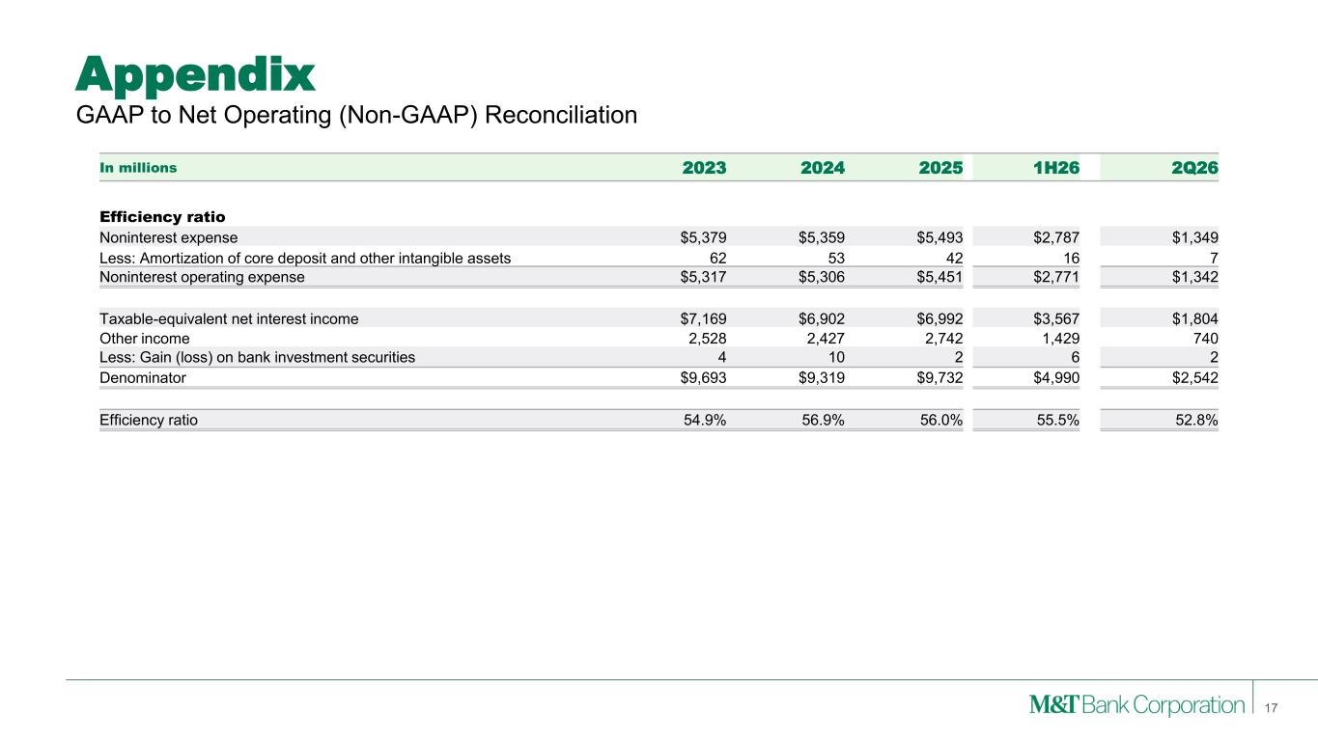
17 GAAP to Net Operating (Non-GAAP) Reconciliation Appendix In millions 2023 2024 2025 1H26 2Q26 Efficiency ratio Noninterest expense $5,379 $5,359 $5,493 $2,787 $1,349 Less: Amortization of core deposit and other intangible assets 62 53 42 16 7 Noninterest operating expense $5,317 $5,306 $5,451 $2,771 $1,342 Taxable-equivalent net interest income $7,169 $6,902 $6,992 $3,567 $1,804 Other income 2,528 2,427 2,742 1,429 740 Less: Gain (loss) on bank investment securities 4 10 2 6 2 Denominator $9,693 $9,319 $9,732 $4,990 $2,542 Efficiency ratio 54.9% 56.9% 56.0% 55.5% 52.8%

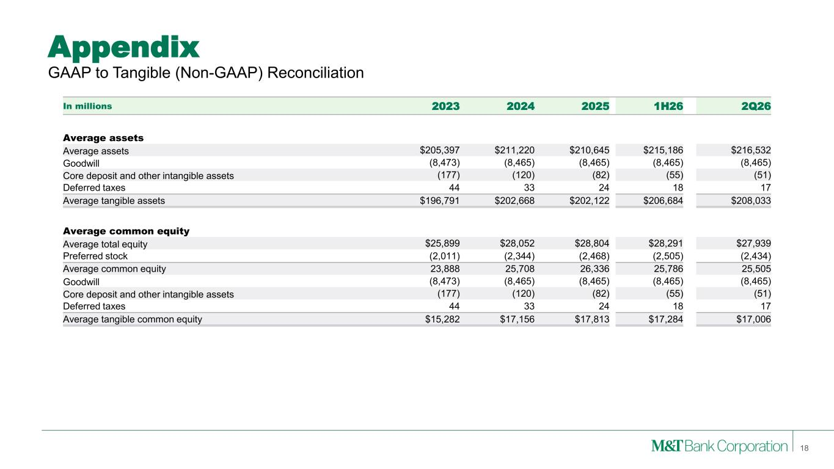
18 Appendix GAAP to Tangible (Non-GAAP) Reconciliation In millions 2023 2024 2025 1H26 2Q26 Average assets Average assets $205,397 $211,220 $210,645 $215,186 $216,532 Goodwill (8,473) (8,465) (8,465) (8,465) (8,465) Core deposit and other intangible assets (177) (120) (82) (55) (51) Deferred taxes 44 33 24 18 17 Average tangible assets $196,791 $202,668 $202,122 $206,684 $208,033 Average common equity Average total equity $25,899 $28,052 $28,804 $28,291 $27,939 Preferred stock (2,011) (2,344) (2,468) (2,505) (2,434) Average common equity 23,888 25,708 26,336 25,786 25,505 Goodwill (8,473) (8,465) (8,465) (8,465) (8,465) Core deposit and other intangible assets (177) (120) (82) (55) (51) Deferred taxes 44 33 24 18 17 Average tangible common equity $15,282 $17,156 $17,813 $17,284 $17,006

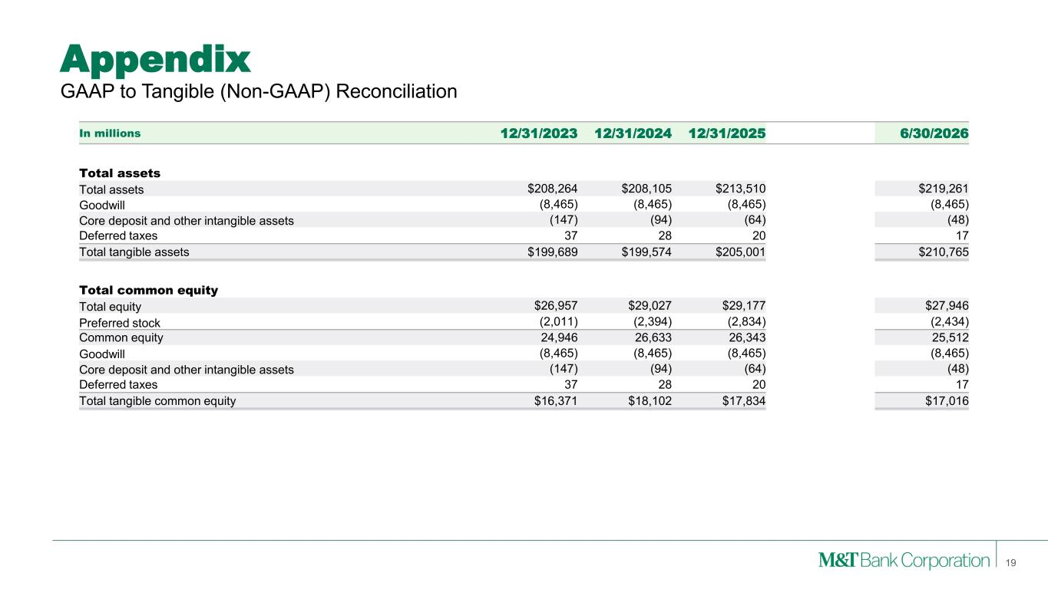
19 Appendix GAAP to Tangible (Non-GAAP) Reconciliation In millions 12/31/2023 12/31/2024 12/31/2025 6/30/2026 Total assets Total assets $208,264 $208,105 $213,510 $219,261 Goodwill (8,465) (8,465) (8,465) (8,465) Core deposit and other intangible assets (147) (94) (64) (48) Deferred taxes 37 28 20 17 Total tangible assets $199,689 $199,574 $205,001 $210,765 Total common equity Total equity $26,957 $29,027 $29,177 $27,946 Preferred stock (2,011) (2,394) (2,834) (2,434) Common equity 24,946 26,633 26,343 25,512 Goodwill (8,465) (8,465) (8,465) (8,465) Core deposit and other intangible assets (147) (94) (64) (48) Deferred taxes 37 28 20 17 Total tangible common equity $16,371 $18,102 $17,834 $17,016

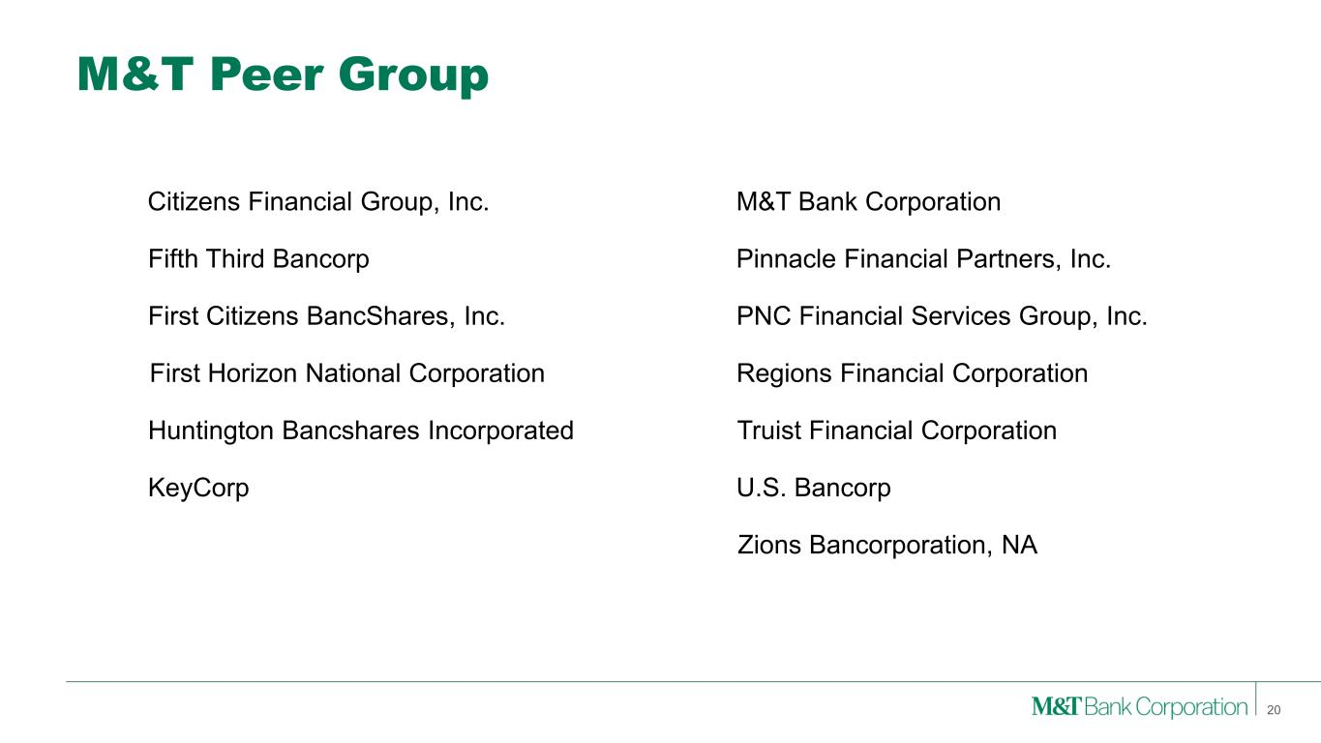
M&T Peer Group PNC Financial Services Group, Inc. Fifth Third Bancorp Regions Financial Corporation First Citizens BancShares, Inc. Huntington Bancshares Incorporated Zions Bancorporation, NA KeyCorp Truist Financial Corporation U.S. Bancorp M&T Bank CorporationCitizens Financial Group, Inc. First Horizon National Corporation 20 Pinnacle Financial Partners, Inc.

